**All** numbers like #44, they are the issue numbers in eService_WorkItems repository.

<https://github.com/Sanjel-Energy-Services/eService_WorkItems/issues>

**eService:**

1. Move HSE reference data to Master Data
   * HSESeverityMatrixtype (115) to ActualSeverity
   * HSEIncidentType (116) to IncidentType
   * HSEPerformanceMetric (117) to PerformanceMetric
   * PotentialSeverity (new) - Add to common type
   * QualityObservationType (new) - Add to common type
2. Update Performance section in eService
   * Update Incident Type, Performance Metric and Actual Severity

Details is in “HSE Change” folder.

1. On Hold - Update locked call sheet with specific permission, not change status, not integration triggerd. #55
   * Ability to modify eService data after call sheet is locked
     + Who has permission?
2. Casing Info string number ordering not correct #37
   * Ryan G reported call sheet #1098300 casing info not ordering correctly. It was created from PRG2101611 - Issue is replicated.
   * Create call sheet from program. Casing string numbers are imported as 1,2,2,2. This leads to a conceptual model question: the different size intermediate casing pipes should be considered as one string or different strings?
   * When a record is modified and updated, the whole string numbers will be reported as 1,2,3,4. If the edited record is not the first one, its string number will be compared to all other string numbers, and calculated as new inserted string.
   * Need to clarify the conceptual model first and give out solution.  
     Jason's answer: the different size intermediate casing pipes should be considered as one string or different strings – one string

So the string numbers in the 3 intermediate record should be 2, not 2,3,4. Is it right?

I guess we # them as Surface is one string, the intermediate is the second string which is made up of 3 parts – need to put in depth order. If 1,2,2,2 or 1,2,3,4 which ever way is correct. Just need to order in depth order as well.

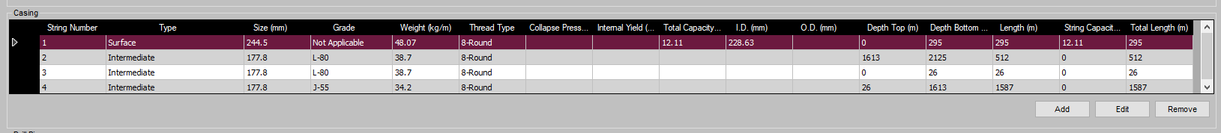

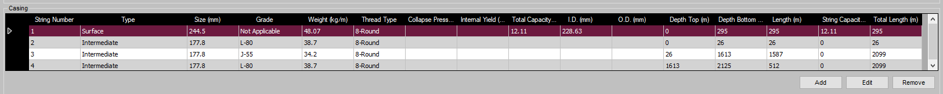

1. Job Date out of range caused rigboard screw up #31
   * Fix 1: In eService, call sheet validation should pop up alert if job date is in future. When a job is going to be started, the expected job date should be no longer than 24 hours. Job creation validation should be in place.
2. Rig not set back to correct rig job listed after a rig job change rig #33
   * A call sheet was created with rig A and changed to rig B later. Rig A is left as open record which will not going to show on the board for future actions.
   * Solution: Set Rig A to last job to be listed.
     + Test Steps:
       - In eServiceOnline, find a rig which job 1 completed already. We call this rig as Rig A.
       - In eService, create a call sheet 2 with with Rig A.
       - In eServiceOnline, it shows Rig A job 2 status as pending or confirmed, you may find the call sheet 2 number in tooltips when you move mouse over Job Date.
       - In eServiceOnline, find another rig with job completed already. We call this rig as Rig B
       - Go to eService, open call sheet 2, change rig from Rig A to Rig B, then save.
       - In eServiceOnline, it should show Rig B job 2 status as pending, you may find the call sheet 2 number in tooltips when you move mouse over Job Date.
       - In eServiceOnline, it should show Rig A job 1 completed.
3. ClientStamp logic defect for manager approval #57
4. Third Party Head & Plugs

* + Was a Third Party Plug Used – Yes/No (dropdown)
  + If No – New fields with plug type, size and quantity appear. If we could import the plug info that would be awesome, but if not maybe the supervisor just selects the options from a dropdown menu.
  + If Yes – New fields with manufacturer, plug type, size, and quantity appear. Some of these fields could be drop downs, but I think manufacturer (and maybe even plug type) would have to be a text field.

Is the plug information as same as “Tubular Plugs” section under “Attachments & Tools” tab?

Can we just add more columns to the “Tubular Plugs” section?

Yes this can go there, I will need to look at how to do that

**eServiceOnline:**

1. Rig Job Postpone function not working correctly. #44
   * Add status to push job to another status
     + In progress – postponed – in progress
2. Job Date out of range caused rigboard screw up #31
   * Fix 2: In eService Online, reschedule a job should have a validation to prevent the error

**eProgram**

1. Expiry date
   * Upon import, a program will default to 8 months (or another reasonable timeframe) that it will remain active
     + Upon import, Status = “Active”
     + After 8 months from import date, status = “Expired”
       - Only “Active” programs will be available to the Rig Board / Call sheets etc
   * This expiry date will be managed within eProgram
     + The date can be extended/modified if required
   * An expired program will not be available for call sheet creation or the other functions of the DRB



* + Program ExpiryDate will default to Generated date + 6 or 8 months or other.
  + There is a selector to modify the Program ExpiryDate

Only these two statuses may not be sufficient, let’s work in this way before further process is discovered.

1. Import additional Items to Miscellaneous Section with 0 Quantity
   * Ability to import 0 quantity items to this section
     + Maintain quantity check on other sections.

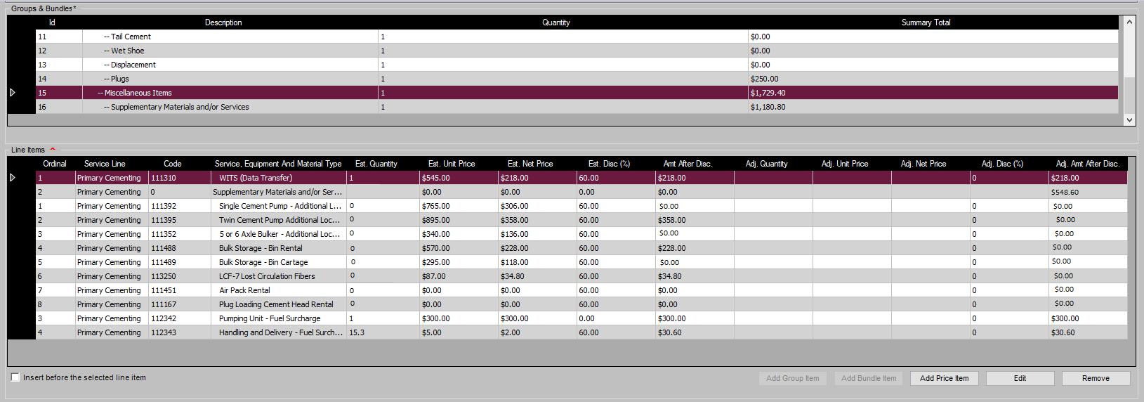

eService Printing

* Do not print 0 quantity items if:
  + If 0 on import and 0 after ticket = do not print
  + If 0 on import and >0 after ticket = Print
  + If >0 on import and 0 after ticket = Print

1. Import pumper count and Job Duration.

In Excel Field, they are in WellboreImport tab, it is per JobType.

In CSV file, they are at the end of file, it is per JobType.

They are called Truck Count and Job Duration.

Truck Count need to be imported to ProgramPumpingJobSection.PumperCount

JobDuration need to be imported to ProgramPumpingJobSection. JobDuration, the imported value is float type, you need to time it with 1440 and truncate the decimals to convert it as int.